**MODUL 4**

**KOMBINASI GERBANG LOGIKA**

NAMA : SALMAA KHOIRUN NISAA’

NIM : L200180019

KELAS : A

1. **Percobaan 1**
2. **Rangkaian**

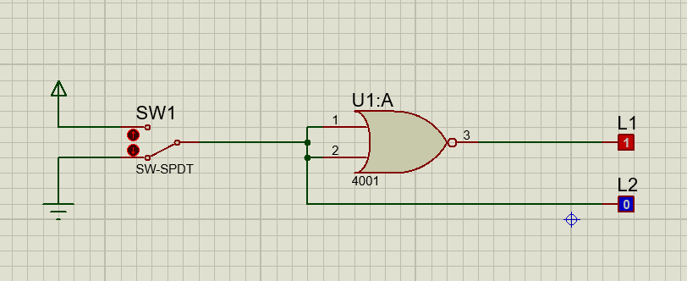

1. **Fungsi Boolean** : L1 = L2+L2 = L2
2. **Tabel Kebenaran**

|  |  |  |
| --- | --- | --- |
| **SW 1** | **L1** | **L2** |
| 0 | 0 | 0 |
| 1 | 1 | 1 |

1. **Diagram Waktu**

|  |  |  |
| --- | --- | --- |
| **L1** | **0** | **1** |
|  |  |
| **L2** | **1** | **0** |
|  |  |

1. **Kesimpulan**

Gerbang NOR pada gambar membentuk logika dari gerbang **NOT**

1. **Percobaan 2**
2. **Rangkaian**

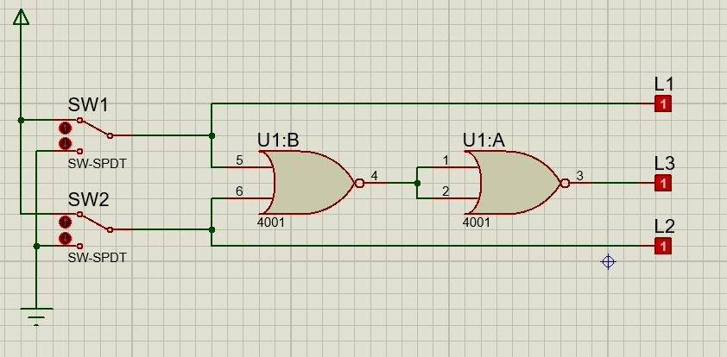

1. **Fungsi Boolean** : L3 = L1+L2 = L1+L2
2. **Tabel Kebenaran**

|  |  |  |  |  |
| --- | --- | --- | --- | --- |
| **SW 1** | **SW2** | **L1** | **L2** | **L3** |
| 0 | 0 | 0 | 0 | 0 |
| 1 | 0 | 1 | 0 | 1 |
| 0 | 1 | 0 | 1 | 1 |
| 1 | 1 | 1 | 1 | 1 |

1. **Diagram Waktu**

|  |  |  |  |  |
| --- | --- | --- | --- | --- |
| **L1** | 0 | 1 | 0 | 1 |
|  |  |  |  |
| **L2** | 0 | 0 | 1 | 1 |
|  |  |  |  |
| **L3** | 0 | 1 | 1 | 1 |
|  |  |  |  |

1. **Kesimpulan**

Gerbang NOR pada gambar membentuk logika dari gerbang **OR**

1. **Percobaan 3**
2. **Rangkaian**

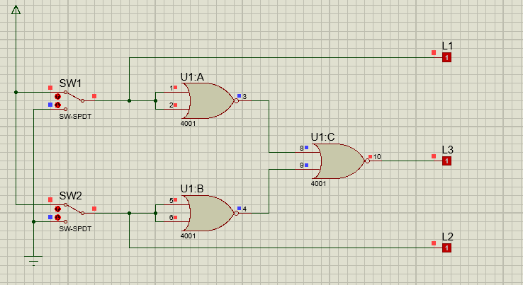

1. **Fungsi Boolean** : L3 = L1+L2 = **L1.L2**
2. **Tabel Kebenaran**

|  |  |  |  |  |
| --- | --- | --- | --- | --- |
| **SW 1** | **SW2** | **L1** | **L2** | **L3** |
| 0 | 0 | 0 | 0 | 0 |
| 1 | 0 | 1 | 0 | 0 |
| 0 | 1 | 0 | 1 | 0 |
| 1 | 1 | 1 | 1 | 1 |

1. **Diagram Waktu**

|  |  |  |  |  |
| --- | --- | --- | --- | --- |
| **L1** | 0 | 1 | 0 | 1 |
|  |  |  |  |
| **L2** | 0 | 0 | 1 | 1 |
|  |  |  |  |
| **L3** | 0 | 0 | 0 | 1 |
|  |  |  |  |

1. **Kesimpulan**

Gerbang NOR pada gambar membentuk logika dari gerbang **AND**

1. **Percobaan 4**
2. **Rangkaian**

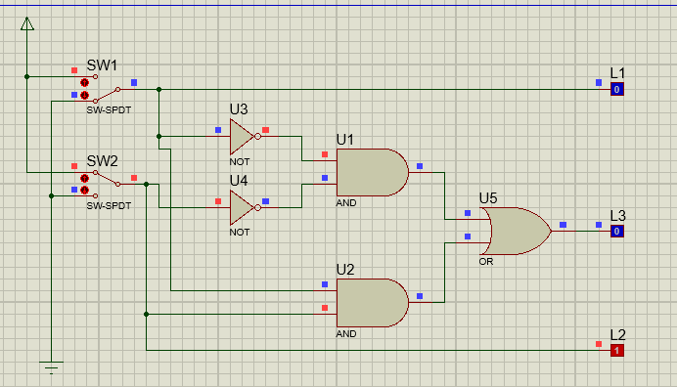

1. **Fungsi Boolean** : L3 = L1.L2 + L1.L2 = L1**O**L2
2. **Tabel Kebenaran**

|  |  |  |  |  |
| --- | --- | --- | --- | --- |
| **SW 1** | **SW2** | **L1** | **L2** | **L3** |
| 0 | 0 | 0 | 0 | 1 |
| 1 | 0 | 1 | 0 | 0 |
| 0 | 1 | 0 | 1 | 0 |
| 1 | 1 | 1 | 1 | 1 |

1. **Diagram Waktu**

|  |  |  |  |  |
| --- | --- | --- | --- | --- |
| **L1** | 0 | 1 | 0 | 1 |
|  |  |  |  |
| **L2** | 0 | 0 | 1 | 1 |
|  |  |  |  |
| **L3** | 1 | 0 | 0 | 1 |
|  |  |  |  |

1. **Kesimpulan**

Kombinasi gerbang pada gambar membentuk logika dari gerbang **XNOR**

1. **Percobaan 5**
2. **Rangkaian**

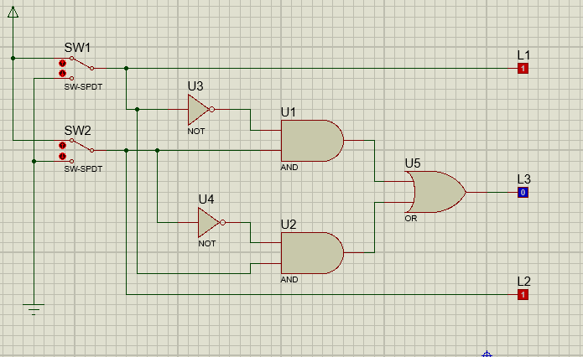

1. **Fungsi Boolean** : L3 = L1.L2 + L1.L2
2. **Tabel Kebenaran**

|  |  |  |  |  |
| --- | --- | --- | --- | --- |
| **SW 1** | **SW2** | **L1** | **L2** | **L3** |
| 0 | 0 | 0 | 0 | 0 |
| 1 | 0 | 1 | 0 | 1 |
| 0 | 1 | 0 | 1 | 1 |
| 1 | 1 | 1 | 1 | 0 |

1. **Diagram Waktu**

|  |  |  |  |  |
| --- | --- | --- | --- | --- |
| **L1** | 0 | 1 | 0 | 1 |
|  |  |  |  |
| **L2** | 0 | 0 | 1 | 1 |
|  |  |  |  |
| **L3** | 0 | 1 | 1 | 0 |
|  |  |  |  |

1. **Kesimpulan**

Kombinasi gerbang pada gambar membentuk logika dari gerbang **XOR**